WORKING WITH SNAPCHAT CONVERSATIONS

To begin, save a working copy of your CONVERSATIONS file. Snapchat provides it as a CSV. I recommend saving it as an Excel File (File -> Save As).
Some Snapchat data files come over in 5 different excel parts and can contain up to 25,000+ messages. Following this process can make reviewing the data much less labor intensive:

Step One: Delete the Legend (Highlight, Right Click, Delete, Entire Row)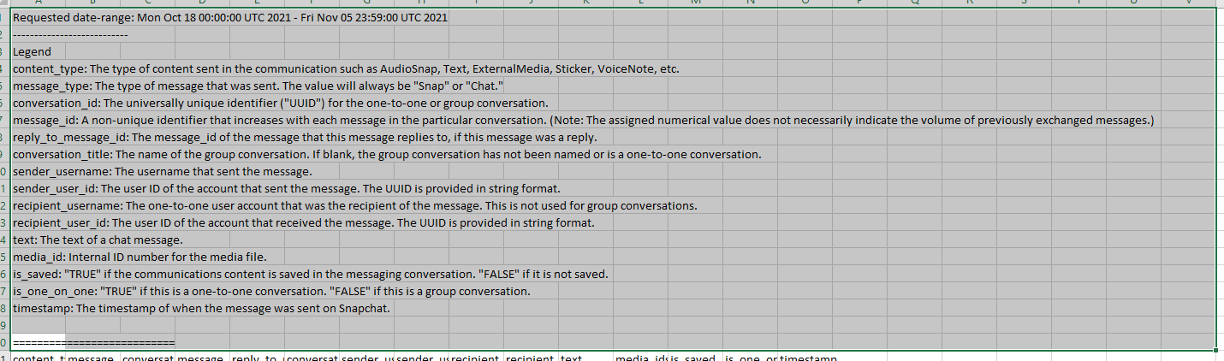

Step Two: Dealing with Multiple Excel Files If there are MULTIPLE conversations excel files, copy and paste the second, third (etc…) underneath the first so all of the data is in one table.

Step Three: Delete Columns that You Don’t Need
Hold down control and click each column you don’t need. Right click the green column headers and choose delete.
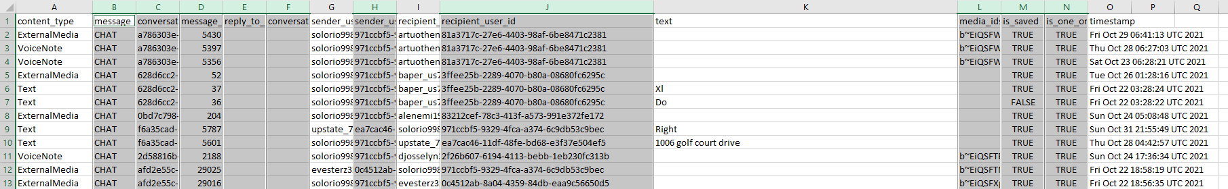

Step Four: Use Excel FILTERS to get rid of Voice Notes, External Medias, etc…
Highlight all of the column headers:
Go to the DATA tab and click FILTER.
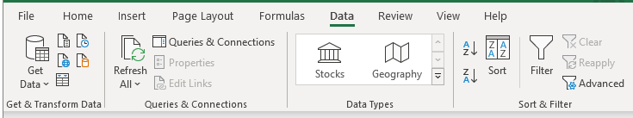
Click the drop down next to content_type:
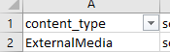
Uncheck TEXT. This will filter the text out and ONLY display all the non-text conversations which are relatively useless.
EITHER Select all your non-text cells (IE: Rows 2-55 or whatever) avoiding selecting the header bar,
OR if there are thousands of rows, Click Find & Select -> Go to Special -> Choose VISIBLE CELLS ONLY.
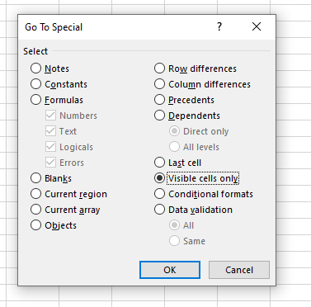
If you choose to do it this way, make sure that you hold down control and click on Row 1 (the header bar) so it is no longer selected. Right click and delete these rows.
Now click the filter arrow next to content type again, and you should only see TEXT. Once you click this, only text based messages will appear.

Step Five: Delete Duplicate Rows
It is always possible that a conversation is duplicated, and we want to narrow that down. This is especially prevalent when you are combining multiple conversations excel sheets provided by Snapchat in multiple data packages. To best handle this, simply remove the duplicate rows.
Press Control + A to select the entire table.
Go to DATA and choose “Remove Duplicates.”
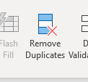
It will then tell you how many it removed.

Step Six: Reorganize the TIMESTAMP
Highlight the entire TIMESTAMP row and unselect (Ctrl click) the header (Timestamp)
Go to the Data tab in Excel and choose “Text to Columns”
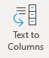

Choose Fixed Width (the default setting) and click Next
Make sure the lines align with each space:
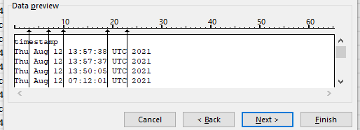
Click “Finish”
This will segregate out your data into separate columns:
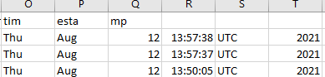
At this point, delete the day column and UTC column. We don’t need them. (Hold down the CTRL button and click on the column letters (IE: E, F, J), right click the column headers and choose Delete.
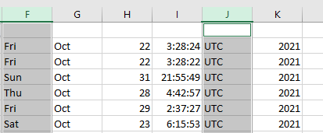
Which cleans this up to look like this:
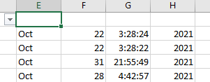
Move your time over (out of the way) by two columns. This is easily accomplished by highlighting the entire column G in the example above (Ctrl + Click), right clicking on the green header (G) and choosing CUT. Then right clicking on Column J and choosing Paste.
Do the same process to move your three cells next to one another in an organized manner (Month, Day, Year) so it looks like below:
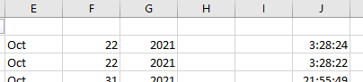
The MONTHS need to get converted from Oct to 10 for this to work. There are numerous ways to do this in Excel. I’ve found the easiest is to use find and Replace. To do this, Highlight your month column by clicking the E. Click Find and Select (under HOME) and Click “Replace.”
Simply tell Excel to FIND Oct and REPLACE with 10.
Repeat this step for each month. If your search warrant captured a year of chats, you’ll have to do this 12 times. If it captured 3 months worth, you’ll only have to do it 3.
Once this is done, your data should look like this:
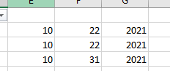
In the blank Column next to the month day and year, click next to it and enter the following formula:
=DATE(G2,E2,F2) Make sure the highlighted columns match yours. If you used different columns than I did, just modify them to match. NOTE: It goes (YEAR, MONTH, DAY) not month, day year.
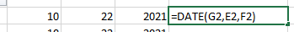
Click Enter and it should convert it to your date.
Then highlight over the bottom right corner and double click. This will APPLY the formula to the entire row.
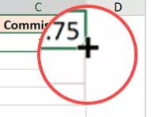
Now your dates should look like this:
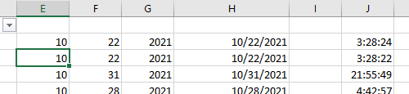

At this point, the dates are stored as formula results and not values. Easy fix. If you have the Kutools, you can just highlight the entire column and choose the option “Display to Actual.”
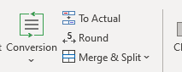
Another option is to just highlight the entire date column (by clicking H in the example above). Right click on H and choose “Copy.” Now right click on the column (H) again and choose Paste Special, which will open a side box. Choose the 123 clipboard under Paste Values.
It should look like this:
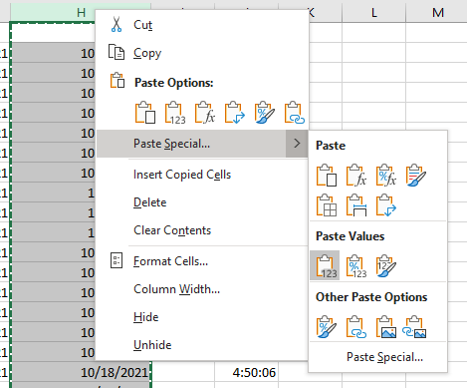
THIS will convert your data from formula results to the values.

Now, clean up your dates by deleting the month, day and year columns, moving over your date and time columns to be next to each other. It should look like this:
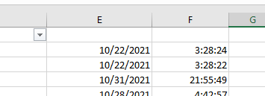

Highlight the entire Column E (date column) and designate it as a Short Date in Excel:
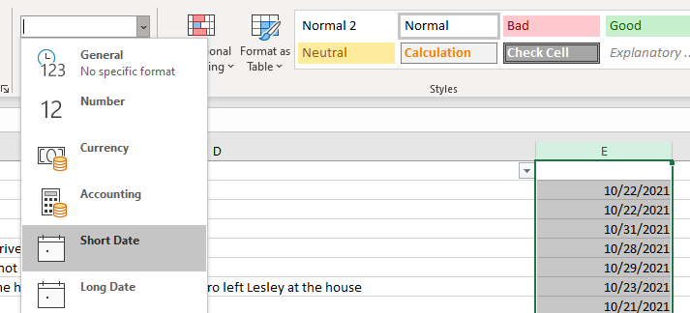

Now do the same for the time column and designate it as a time:
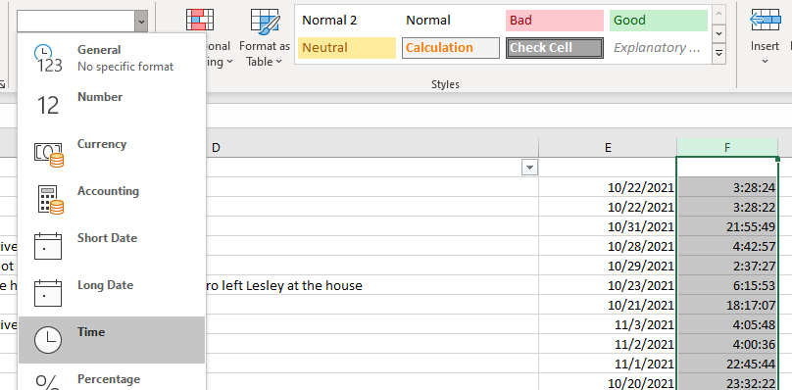
Label your headers:
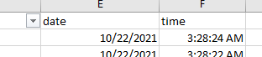

OPTIONAL Step Seven: Add Message ID numbers (if desired)
At this point, I typically add message ID numbers for each message so that they are easier to reference in court or in my report. This is easy.
Right click the top Column B and click “Add Column.” This will add a Column before it.
In Row 1 (header) type “ID” or something similar.
In Row 2, 3 and 4 type “1” “2” and “3”
Highlight rows 1, 2, and 3 and click the bottom right corner again to tell Excel to continue numbering the entire column in this format.
It should look like this:
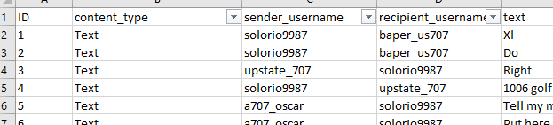

OPTIONAL Step Eight: Format into a more professional presentation
Recognizing that this case will likely go to court, I typically format my Excel a bit to lock Rows 1 and 2, add my agency logo and a case number, get rid of the “content-type” column, and create something that looks like this:
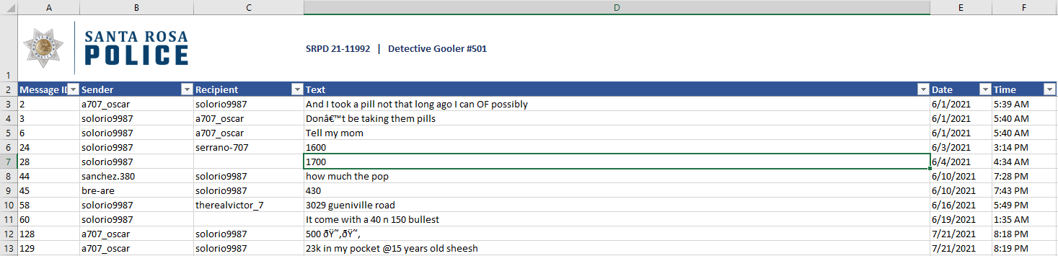

Step Nine: Resetting the “Filters” and sorting your data to make it easy to review.
Highlight all of the headers (for the new columns too such as ID, date and time) and under the “Data” tab click Filter twice. This will turn off the old filtering and reset it to the new headers / data.

Under the VIEW tab, choose “Freeze Pains” and tell Excel to freeze your top row. This will ensure it isn’t sorted and it stays on top as you scroll through your messages:
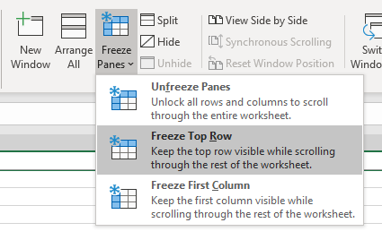

At this point, click the SORT button on the data tab and tell Excel how to sort the messages.
Tell Excel to sort by DATE (old to new or new to old, depending on your preference) and then TIME.
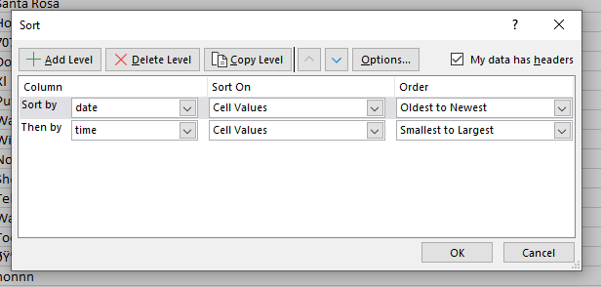

At this point, the Snapchat conversations should be much easier to sort through and in chronological order as they were sent / received:
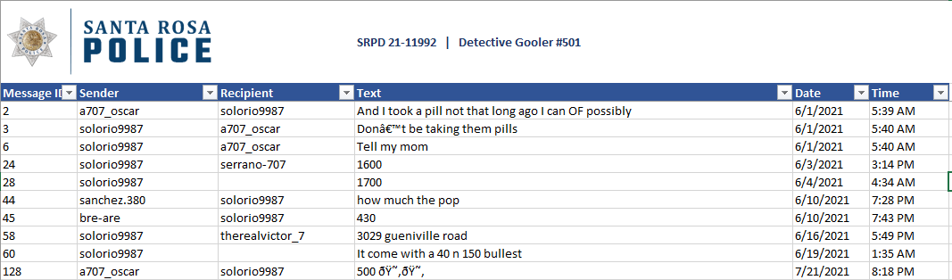

Don’t forget to take advantage of Filtering and Find functions.
You can filter columns so that you only review chats between certain targets:
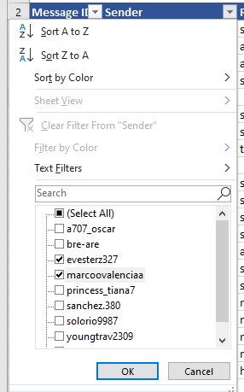
And you can use the FIND feature to search certain keywords (gun, gat, piece, 9, 9mm, etc....) relevant to your investigation:
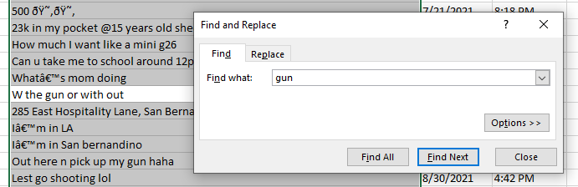
OPTIONAL Step Eight: Add a column to mark conversations of relevance (if desired)
I typically will add a very small Column A (by right clicking “A” and choosing “Insert Column”:
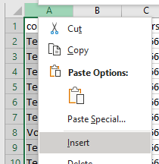

As I work through the Snapchat conversations, I will add an “x” or whatever you choose into that column of conversations of relevance to my investigation.
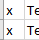

At the end (as shown in class), you can Filter that column to only show the conversations marked with an “X” and that way you hide all the non-relevant conversations.

